**Host Network:**

In Docker, the host networking mode allows a container to directly use the network stack of the Docker host. When you run a container in host networking mode, it essentially shares the network namespace with the host system. This means the container does not get its own isolated network stack but uses the same network interfaces as the host.

Here are some key points about Docker host networking:

1. Same Network Namespace: The container shares the same network namespace as the Docker host. This implies that the container can directly access network interfaces, ports, and services running on the host without any additional network address translation (NAT) or port mapping.
2. Port Binding: If a service inside the container is listening on a specific port, that port is directly exposed on the host. There is no need to explicitly publish or map ports, as the container uses the host's network stack.
3. Networking Performance: Since there is no additional network encapsulation or translation, containers in host networking mode may have better networking performance compared to containers using other networking modes.
4. Port Conflicts: Be cautious about potential port conflicts. If a service is already running on a specific port on the host, attempting to run a container with a service that uses the same port could lead to conflicts.

To run a Docker container using host networking, you use the --network host option with the docker run command. Let’s do a practical and see how it works:

* Create a container using nginx image using host network.

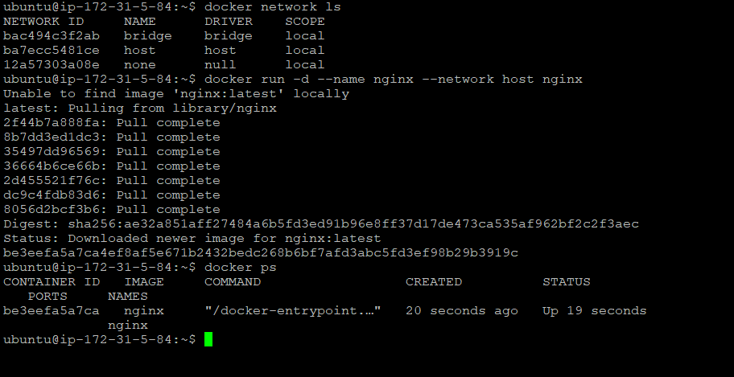

* If you see above screenshot , we haven’t exposed any port while creating the container.
* Nginx use to run in port 80. In our case we are using Host network, so the container is using the Host’s network.
* In the below screenshot we will inspect the host network and see the container’s ip and network details.
* You will see there is no separate IP assigned to our container, it is using Host’s own network.
* If you remember, we have seen separate ip assigned to our container while using Default bridge network. To understand easily here’s the main difference with Host network and Default bridge network.

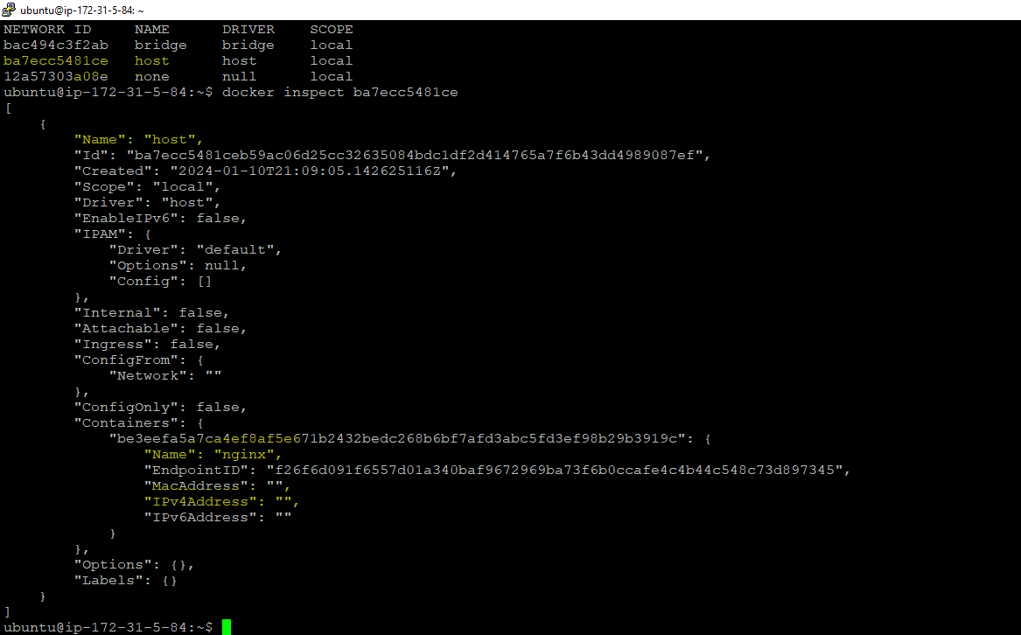

Now check your app is running or not in browser. Use the public IP of your host machine and runin port 80.



Using the host network mode in Docker has both advantages and disadvantages. It's important to carefully consider your use case and requirements before opting for host networking. Here's a breakdown:

Advantages:

* Performance:

Low Overhead: Host networking mode can offer better networking performance because it eliminates the overhead of network encapsulation and NAT that is present in other Docker networking modes.

* Simplified Configuration:

Direct Access: Containers in host networking mode have direct access to the host's network stack, making it simpler to configure and allowing containers to easily communicate with services running on the host.

* Port Binding:

No Port Mapping: Ports used by containers are directly exposed on the host without the need for explicit port mapping, reducing the configuration complexity.

Disadvantages:

* Security Concerns:

Increased Exposure: Containers in host networking mode have greater access to the host system, potentially increasing the security risk. They share the same network namespace as the host, allowing direct access to host resources.

* Port Conflicts:

Potential Conflicts: Since containers share the host's network stack, conflicts may arise if a service in the container tries to use a port that is already in use by another service on the host.

* Isolation:

Lack of Network Isolation: Host networking mode lacks the network isolation that other Docker networking modes provide. This might not be suitable for scenarios where you want containers to operate in a more isolated environment.

* Compatibility:

Platform Dependence: Host networking might not be suitable for multi-host environments or specific platforms where there are restrictions on sharing the host's network namespace.

Use Cases:

1. High-Performance Applications: Host networking can be beneficial for applications that require low latency and high network throughput.
2. Legacy Integration: When migrating legacy applications into containers, host networking may simplify integration with existing network configurations and services.
3. Single-Host Environments: In scenarios where security concerns are mitigated and you have a single host environment, host networking might be appropriate.

*In summary, host networking in Docker is suitable for specific use cases where performance and simplicity outweigh the security and isolation concerns. However, for most applications, especially those with security considerations or that require multi-container communication, other Docker networking modes might be more appropriate. Always carefully evaluate the trade-offs before choosing a networking mode for your Docker containers.*